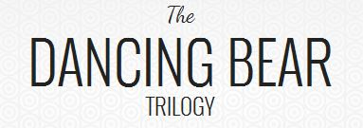
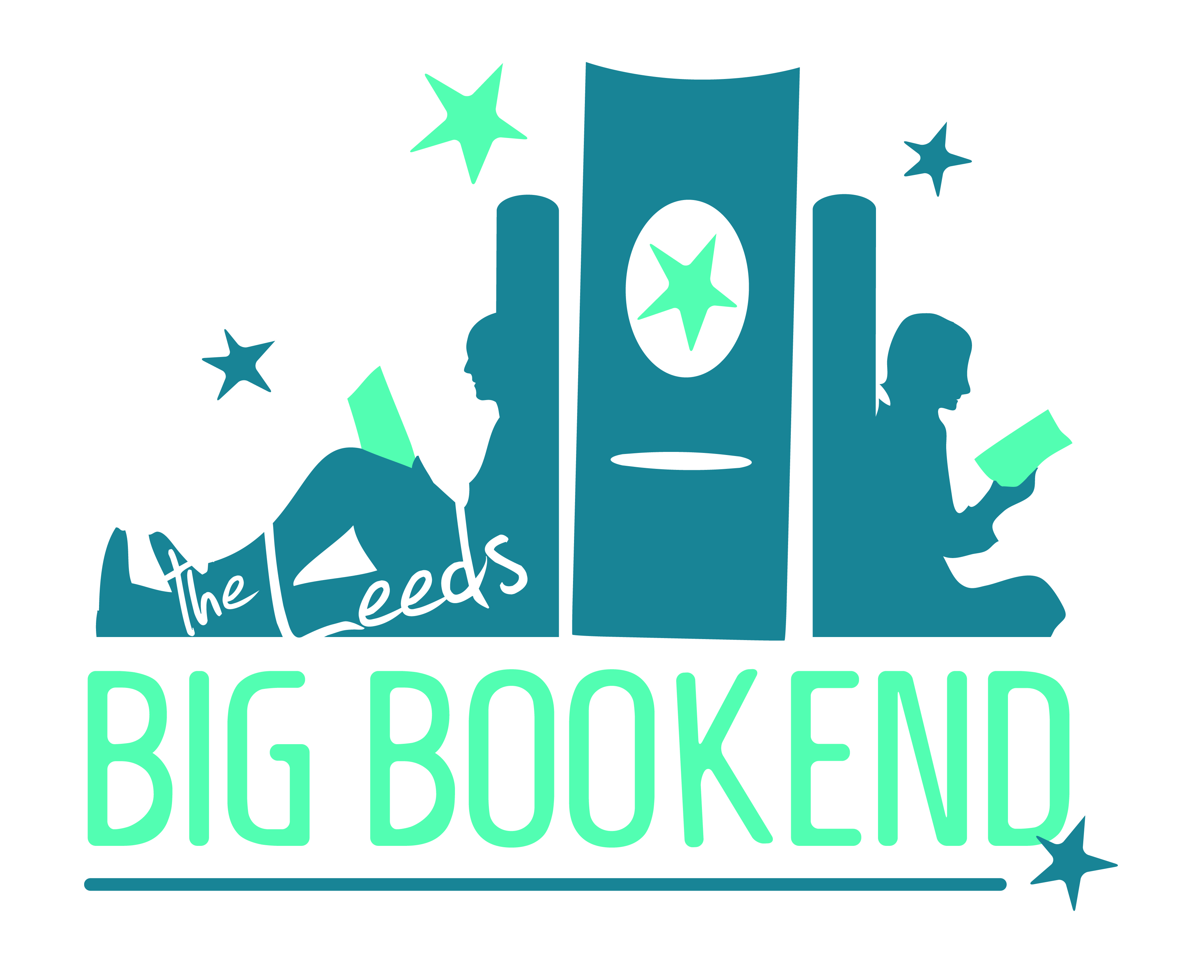

Alphabet Club Book Submission Form
Please complete the form and return it by email to jamie@dancingbeartrilogy.com. We will be in touch to let you know whether your contribution has been chosen for publication and with more details about the book. Please note, we may edit stories for inclusion in the book, but will endeavour to do this sensitively.
The closing date for submissions is Sunday 1st November 2015. Thanks for taking part!
Name:
Email:
Phone number:
Postcode:
Type of contribution (story, essay, picture, poetry)
Title of contribution:

Contribution:

Please continue overleaf…

